Name: ________________________________ Date: ___________________________________

Class: _________________________________ Teacher: ___________________________________

# Math Mini Quiz 5

This Mini Quiz, we’re going to explore the math concepts that you’ve learned so far in this unit. This assignment should take you about **20 minutes**.

1) Mark each of the following situations as exponential decay (ED), exponential growth (EG), or linear (L). Justify your answer.

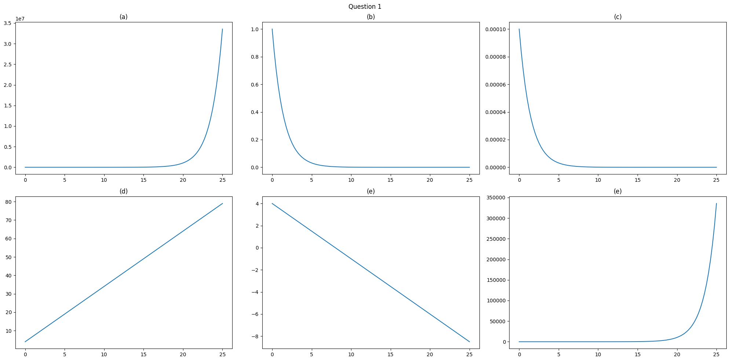

a) *EG - curves up from 0*

b) *ED - gets infinitely close to 0 as x increases*

c) *ED - gets infinitely close to 0 as x increases*

d) *L - shows a straight line, indicating a constant rate of change*

e) *L - shows a straight line, indicating a constant rate of change*

f) *EG - curves up from 0*

You’re taking a shower and you realize you have a mold problem. The mold currently covers one whole tile of your shower.

You do some research and you learn that each mold spore releases 2 new ones when it dies, that’s to say *each mold spore turns into two*. This cycle happens once every day.

You realize one whole tile is covered in mold.

2) Write a function *M(d)* to represent the number of tiles covered with mold after ***d*** days.

*M(d) = 1(2)d*

3) Graph your function on the plot below.

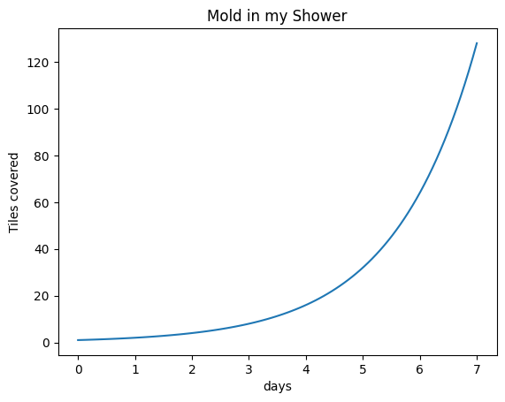

4) Is this model exponential decay (ED), exponential growth (EG), or linear (L)? How do you know?

*Exponential Growth because it increases with a curve, doubling each day. We can also tell from looking at the equation and seeing that it is of the form y = abx*

5) If you have 100 bath tiles in the shower, how long will it take for the whole shower to be covered?

*To answer this question, look the way the function progresses*

| *Day* | *0* | *1* | *2* | *3* | *4* | *5* | *6* | *7* |
| --- | --- | --- | --- | --- | --- | --- | --- | --- |
| *Moldy Tiles* | *1* | *2* | *4* | *8* | *16* | *32* | *64* | *128* |

*So, after the 7th day, all 100 tiles will be covered*